1. Determine the current *Ix* through the 10-Ω resistor in Fig. 1, using superposition theorem. [**Ans. :** -1 A]

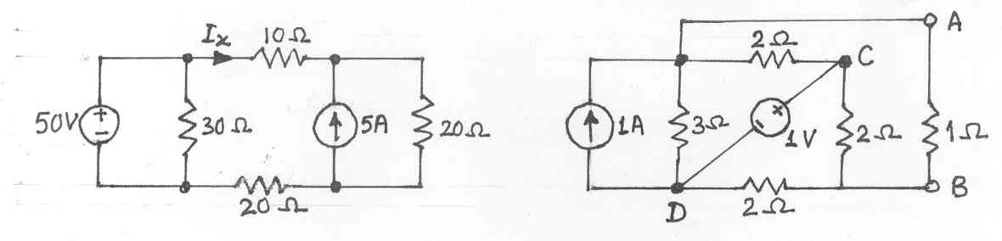 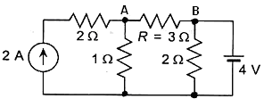

**Fig. 1 Fig. 2**

1. Determine the current through *R* = 3 Ω resistor (from A to B) in the circuit shown in Fig. 2, using superposition theorem. [**Ans. : -**0.5 A]
2. Determine the current through 4-Ω resistor (from A to B) in the circuit shown in Fig. 3, using superposition theorem. [**Ans. :** 0.516 A]

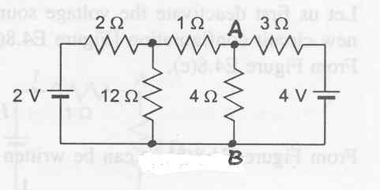 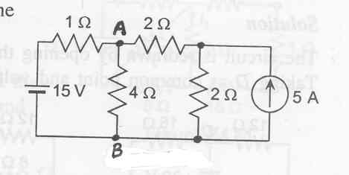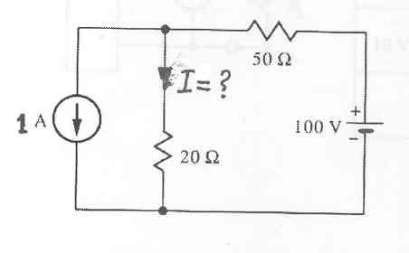

**Fig. 3** **Fig. 4** **Fig. 5**

1. Find the current through 4-Ω resistor in the circuit shown in Fig. 4, using superposition theorem. [**Ans. :** 2.916 A]
2. Find the current through 20-Ω resistor in the circuit shown in Fig. 5, using superposition theorem. [**Ans. :** 0.714 A]
3. For the circuit shown in Fig. 6, determine the current in 50-Ω resistor with the reference direction shown, using the principle of superposition. [**Ans. :** 0.0455 A]

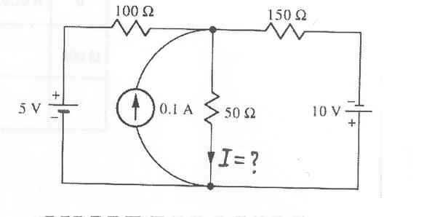 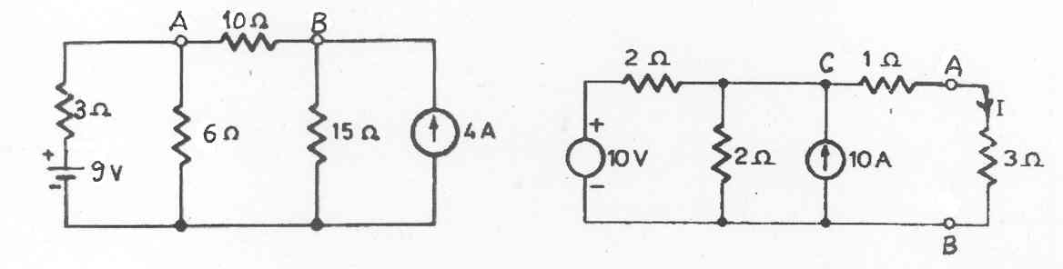

**Fig. 6** **Fig. 7**

1. Find the current *I* in 10-Ω resistor in the circuit shown in Fig7, using Thevenin’s theorem. [**Ans.**]

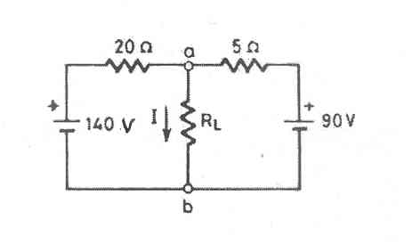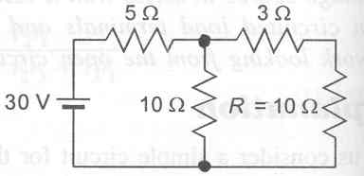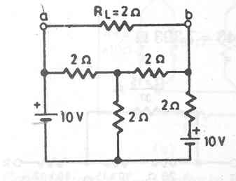

**Fig. 8** **Fig. 9 Fig. 10**

1. Find Thevenin’s equivalent at terminals a-b of the network shown in Fig. 8.   
    [**Ans. :** 100 V, 4 Ω]
2. By applying Thevenin’s theorem, find the voltage across the resistance *R* in the circuit shown in Fig. 9. [**Ans. :** 12.24 V]
3. Solve the above problem, by applying Norton’s theorem. [**Ans. :** 12.24 V]
4. Find the current in *R*L in the circuit of Fig. 10 by using Thevenin’s theorem, and then verify your results by using loop current method. [**Ans. :** 0.625 A]
5. Solve Prob. 2, by using Thevenin’s theorem. [**Ans. : -**0.5 A]
6. Solve Prob. 3, by using Thevenin’s theorem. [**Ans. :** 0.516 A]
7. Find the current in the 3-Ω resistor of the circuit shown in Fig. 11, using Thevenin’s theorem. [**Ans. :** 5.143 A]

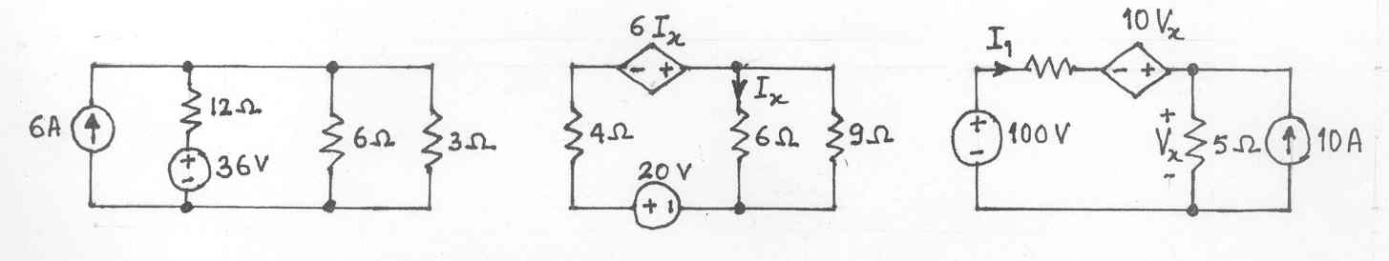

**Fig. 11** **Fig. 12**

1. In the circuit shown in Fig. 12, determine the current through 1-Ω resistor connected across *A-B*, using superposition theorem. Verify the result using Thevenin’s theorem.

[**Ans. :** 406.25 mA]

1. Find Thevenin’s equivalent circuit for a dc power supply that has a 30-V terminal voltage when delivering 400 mA and a 27-V terminal voltage when delivering 600 mA.

[**Ans. :** 36 V, 15 Ω]

1. Determine the current through the 3-Ω resistor in the circuit of Fig. 13, by using Thevenin’s theorem. [**Ans. :** 3 A]

 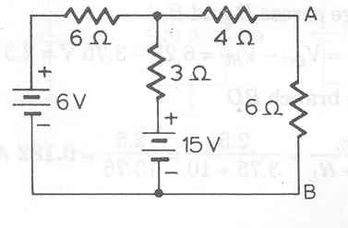

**Fig. 13 Fig. 14**

1. Determine the current through 6-Ω resistor connected across *A-B* in the circuit of Fig. 14, by using Thevenin’s theorem. [**Ans. :** 1 A]
2. In the circuit shown in Fig.15, determine (*a*) the value of *R* so that the load of 20 Ω draws maximum power, and (*b*) the value of the maximum power drawn by the load.

[**Ans. :** (*a*) 30 Ω, (*b*) 180 W]

1. Using Thevenin’s theorem, calculate the current that would flow in a 76-Ω resistor connected between terminals A and B of the circuit shown in Fig. 16*.* [**Ans. :** 10 mA]

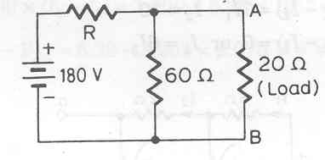 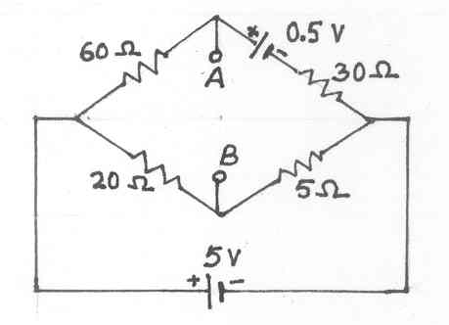 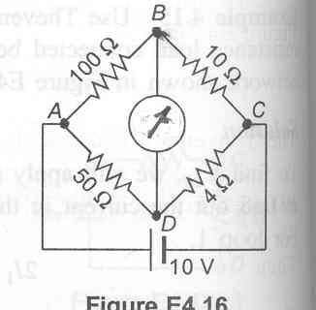

**Fig. 15** **Fig. 16** **Fig.17**

1. A Wheatstone bridge is shown in Fig. 17. The galvanometer connected across *B-D* has a resistance of 20 Ω. Using Thevenin’s theorem, compute the current through this galvanometer. [**Ans. :** 5.12 mA]

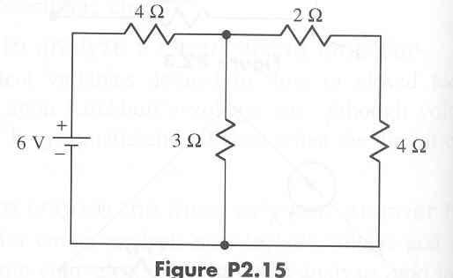 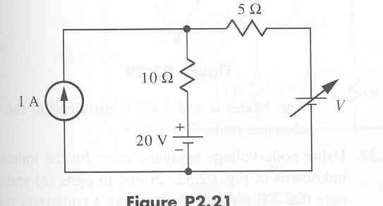

**Fig. 18** **Fig. 19** **Fig. 20**

1. For the circuit shown in Fig. 18, (*a*) Find the current in 3-Ω resistor. (*b*) What resistance, replacing the 3-Ω resistor, would draw one-half the current in part (*a*) ? [**Ans. :** (*a*) 0.667 A; (*b*) 8.4 Ω]
2. For the circuit shown in Fig. 19, find the value of *V* to make the current in the 5-Ω resistor to be zero. [**Ans. :** 30 V]
3. Find the current in the 9-Ω resistor of the circuit shown in Fig. 20, using Thevenin’s theorem. [**Ans. :** 2 A]